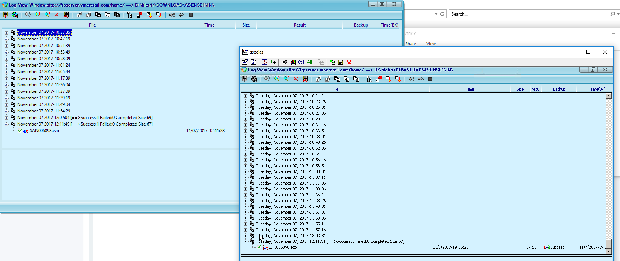

From prod svr windows 2003. Time stamp of the file is same as source ftp server when bestsync do the transfer

From my pc windows 10. Time stamp of the file is same as my pc when bestsync do the transfer